Software Requirements Specification

for

SE Spring 2025 – E-Commerce Platform

Version 1.0 approved

Prepared by Nathan Jones  
ndj4@msstate.edu

Software Engineering CS6214

February 16, 2025

Table of Contents

1. Introduction 1

1.1 Purpose 1

1.2 Document Conventions 1

1.3 Intended Audience and Reading 1

1.4 Product Scope 1

1.5 References 2

1.6 Product Perspective 2

1.7 Product Functions 2

1.8 User Classes and Characteristics 3

1.9 Operating Environment 3

1.10 Design and Implementation Constraints 3

2. System Features 4

2.1 User Account 4

2.2 User Account – Admin 4

2.3 User Account – Buyer 5

2.4 User Account – Seller 5

2.5 Product system 6

3. Other Nonfunctional Requirements 7

3.1 Performance Requirements 7

3.2 Security Requirements 7

3.3 Software Quality Attributes 7

4. Other Requirements 7

Revisions

|  |  |  |  |
| --- | --- | --- | --- |
| Version | Author | Description of Version | Date Completed |
| 1.0 | Nathan Jones | Initial Draft | 02/16/2025 |
|  |  |  |  |
|  |  |  |  |
|  |  |  |  |
|  |  |  |  |

# Introduction

The Software Requirements Specification (SRS) is designed to document and describe the agreement between the customer and the developer regarding the specification of the software product requested. Its primary purpose is to provide a clear and descriptive “statement of user requirements” that can be used as a reference in further development of the software system. This document is broken into several sections used to logically separate the software requirements into easily referenced parts. This Software Requirements Specification aims to describe the Functionality, External Interfaces, Attributes and Design Constraints imposed on Implementation of the software system described throughout the rest of the document. Throughout the description of the software system, the language and terminology used should be unambiguous and consistent throughout the document.

## Purpose

The following document provides the functions and specifications of the E-Commerce Platform for the Spring 2025 CS6214 Lab. The purpose of this document is to outline the requirements and specifications as agreed upon by the customer and developer. The customer for this product is Lab Instructor Maxwell Liam.

The document will outline all specifications and requirements for each interface, backend system, and database. The document will outline the interfaces and components of each system.

## Document Conventions

The following document follows conventions outlined for SRS development as documented in IEEE Std. 830-1998. Requirements specified at the high level in this document will be inherited in all forms for detailed requirements. Deviations from this hierarchy will be documented by the developer in those areas as needed. The document will utilize Times New Roman, 11 font, for the main body text and Times 14 and 18 font for headings.

## Intended Audience and Reading

The following document is intended for the customer, Lab Instructor Maxwell Liam and Dr. Charan Gudla, as well as those performing development of the project. The project manager, developers, marketing staff, testers, users, and editors will utilize this document to understand the requirements and techniques utilizing in the development of the software.

## Product Scope

The E-Commerce Platform is a web application that will allow users to search, compare, buy and return different types of products from different sellers. The platform will allow multiple sellers to sell their products on a platform that will reach many customers. The customers will be able to search an abundant assorted products from their web browser. Users, sellers, and administrators of the system will be able to access the system and components they wish from ease from a web browser.

## References

1.5.1. IEEE Std. 830-1998; <https://ieeexplore.ieee.org/stamp/stamp.jsp?tp=&arnumber=720574>

1.5.2 Django Project Platform; <https://www.djangoproject.com/>

1.5.3 MySQL Database Programming; <https://dev.mysql.com/doc/>

1.5.4 Python; https://www.python.org/

1.5.5 CSE6214 Lab “Project Topic: An e-commerce platform” Overall Description

## Product Perspective

The E-Commerce Platform is a new system that developed from the ground up. Users will access the web interface to search for products from multiple sellers. The sellers will have a separate web interface to add, sell, and receive payments. The administrators of the website will have a separate web interface to approve or block new user accounts and products as well as oversee other user actions.

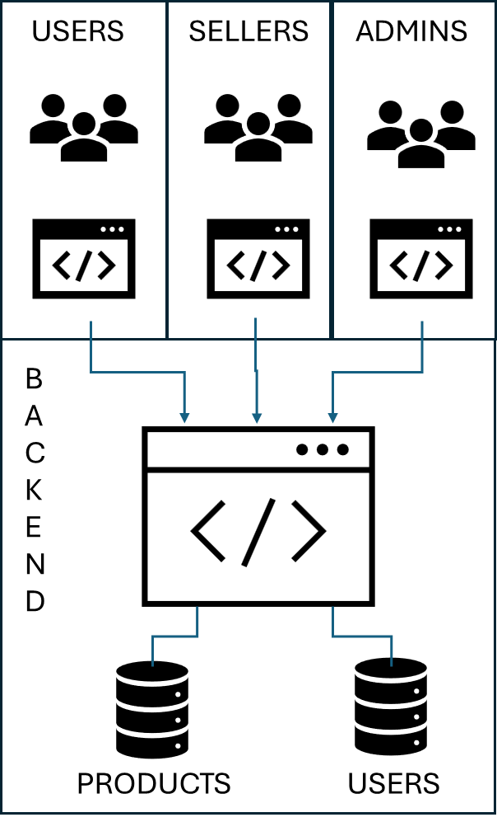

## Product Functions

The E-Commerce Platform will perform the following functions as outlined below:

* User Interface
  + Buyer UI
    - Buyers will be able to register utilizing their email and password.
    - Buyers will be able to login to the system to begin searching.
    - Buyers will be able to search for products of different sellers by utilizing a general search or by category.
    - Buyers will be able to compare products.
    - Buyers will be able to buy products requested.
    - Buyers will be able to process returns.
  + Seller UI
    - Sellers will be able to register an account utilizing their company name, email and password.
    - Sellers will be able to login into the system to sell products.
    - Sellers will be able to add and delete products.
    - Sellers will be able to keep up with the inventory of products, description of products, and pictures of products.
    - Sellers will be able to receive payments for their available products.
  + Admin UI
    - Administrators should be able to approve users and sellers.
    - Administrators should be able to block users and sellers.
    - Administrators should be able to assign administrative rights to other users.
    - Administrators should be able to add or delete products as needed.
    - Administrators should be able to modify other user accounts as needed.
    - Administrators should be able to modify product information as needed.
* Backend Interface
  + The website UI will interface with a backend managed by Django and Python
  + The system will provide interface and run queries to the backend Databases to support functions outlined in the UI.
* Database
  + A database of users will be established.
  + A database of products will be established.

## User Classes and Characteristics

Users of the E-Commerce Platform will consist of Buyers, Sellers, and Administrators. Buyers will have working knowledge of navigating websites, utilizing webpage search features, and buying products from a web environment. Sellers will have knowledge of setting up accounts in a web environment and they will have ease of use to add products and monitor products being sold on the platform. Administrators will be E-Commerce personnel that will be able to administratively manage user accounts, manage product information, and administratively perform database manipulations as needed.

## Operating Environment

The software will need to be able to work in a cloud-based system as determined by the customer. For purposes of development and testing, the software will be stored on local server/machine capable of accessing and setting up the database and interface. The system will be developed utilizing MySQL as the database management system and it will interface using Python with Django. Django will be utilized to manage user accounts and administrative tools. The front end will be developed utilizing HTML5, JavaScript, and PHP as required.

## Design and Implementation Constraints

Design:

* Languages: Python with Django, HTML5, PHP, JavaScript, CSS
* Database: MySQL
* Server: As outlined by Customer (testing performed on local server)
* Administration: The customer will be responsible for monitoring user and product information as well as minor database manipulation.
* Developer: The developer will be responsible to any interface changes and database updates that require updates to table configurations.

Constraints:

* The software must be able to run on Microsoft Edge 133.0 and Google Chrome 133.0 or later.
* Users must be able to login and create their own accounts.
* Administrators should approve these accounts.

# System Features

The following will outline the functional features of the software. This section will give detailed descriptions of the features, responses, and requirements. Requirements are going to be outlined as General User and Administrator systems (1.0), Buyer system (2.0), Seller system (3.0), and Product system (4.0).

## User Account

2.1.1 Description and Priority

User accounts will be established with three classes which include Buyers, Sellers, and Admin. These accounts will look similar in nature; however, they will have different options to be able to execute in their profile. Each user will have separate profiles that will be set up using their email address.

2.1.2 Stimulus/Response Sequences

Users will be prompted to register for an account on their first visit to the website. Buyers will not be prompted until they are ready to purchase an item. Each account feature will be discussed in their corresponding section. A database will be maintained of users, users’ information, and access privileges.

2.1.3 Functional Requirements

Each user account will have a minimum set of requirements. These requirements are stated below.

REQ-1.1: A user database will be created with user email, name, address, phone number, password, and access privileges.

REQ-1.2: The user will provide User email while creating an account.

REQ-1.3: User password will be at least an 8-digit alphanumeric password with at least one special character and one upper case letter.

REQ-1.4: User last name will be provided in a separate field.

REQ-1.5: User first name will be provided in a separate field.

REQ-1.6: User authentication will be provided using the email address of the user.

## User Account – Admin

2.2.1 Description and Priority

Users with Admin accounts will be established. The Admin users will have access to update all users accounts and all product information. The Admins will be able to approve, block other users, and delete accounts.

2.2.2 Stimulus/Response Sequences

Admin users will be prompted to approve user accounts. Admin Users will provide a means to update Buyer, Seller, and Admin privileges to user accounts. The Admin users will be able to disapprove user accounts, and they will be able to delete user accounts as needed. The Admin users will be given an interface that allows them to see all active users, pending user accounts, deleted accounts, and active / inactive product information. The admin will be given an interface to manipulate products as needed including adding and deleting products. More on product manipulation will be discussed in the section on products.

2.2.3 Functional Requirements

REQ-1.7: Admin user interface to see all pending, active, and deleted accounts.

REQ-1.8: Admin user interface to approve user accounts.

REQ-1.9: Admin user interface to view and update active accounts.

REQ-1.10: Admin user interface to update/change privileges of user accounts.

REQ-1.11: Admin user interface to block / delete user accounts.

REQ-1.12: Admin user interface to view all products by category and seller.

REQ-1.13: Admin interface to add and delete products.

REQ-1.14: Admin interface to change / update products individually.

REQ-1.15: Admin interface to change/ update or delete multiple products at a time.

## User Account – Buyer

2.3.1 Description and Priority

Users with Buyer accounts will be established. The Buyer account users will have access to view all active products from all sellers. The Buyers will also be able to purchase products utilizing a cart system and provide purchasing information at checkout. Users will be able to return products as needed.

2.3.2 Stimulus/Response Sequences

Users can access the website and begin searching for products without an account. Once a product is added to a cart, the user is prompted to create an account. The user will create an account using their email and password. The user may select multiple items to checkout and the user may delete items from their cart. When users are ready to checkout, they will be prompted for shipping and billing information such as address, phone number, and payment information. Buyers will also have a way to review orders and perform returns of those orders.

2.3.3 Functional Requirements

REQ-2.0: Buyers can access the website and begin shopping without an account.

REQ-2.1: Buyers will have a cart interface.

REQ-2.2: Buyers will be prompted to create an account with the cart that is populated with an item.

REQ-2.3: Buyer will utilize their email and password to create an account.

REQ-2.4: Buyer can select multiple items in their cart.

REQ-2.5: Buyer can delete items from their cart.

REQ-2.6: Buyer will supply phone number, shipping, and billing address information.

REQ-2.7: Buyer will supply payment information.

REQ-2.8: Buyer will be prompted with a successful purchase.

REQ-2.9: Buyers will have an interface to review previous purchase orders.

REQ-2.10: Buyers will have an interface to return items.

## User Account – Seller

2.4.1 Description and Priority

Users with seller accounts will be established. The seller be able to add products to their account for sale. The products will be activated by the seller such that the general user can view them.

2.4.2 Stimulus/Response Sequences

Sellers will be able to view the website and select an option to become a seller. The seller will be prompted with an interface to create a seller account. The seller will utilize their email and password to create an account. Once an account is approved and set up, the seller will begin populating their products in their account. The seller will supply the products name, manufacturer, price per unit, categories, and number of units in stock. The seller will provide information about the business that sells the products such as address, phone number, and website. The seller will have an interface to view all products. The seller will have an interface to update the product’s information and delete the product. The user will have the ability to view users that have purchased their products and quantity.

2.4.3 Functional Requirements

REQ-3.0: Seller can access the website and begin setting up a seller user account.

REQ-3.1: Sellers will utilize email and password to create an account.

REQ-3.2: Sellers will provide user information such as address, phone number, and website.

REQ-3.3: Sellers will be provided with an interface to quickly add products to their store. The products will include name, manufacturer, price per unit, categories, and number of units in stock.

REQ-3.4: Seller will have an interface to view all products.

REQ-3.5: Seller will have an interface to update/change product information.

REQ-3.6: Seller will have an interface to delete the product.

REQ-3.7: The seller will have an interface to view users that have purchased their products and the order number.

## Product system

2.5.1 Description and Priority

A database will be utilized to maintain all of the product’s information. A separate database will be utilized to keep up with purchase order information and returns. These two databases will interface to ensure that the inventory of the products is maintained.

The initial UI on the E-Commerce will display the latest added products and most shopped products. It will also allow interfaces to the cart and user account information.

2.5.2 Stimulus/Response Sequences

As products are created, database entries are created that house unique identifiers for each product. Information such as product name, manufacturer, category(ies), price per unit, unit type, number in stock, and photograph/picture of the product will be maintained in the database. A separate table of units and categories will also be maintained.   
  
For purchases, a separate database will be maintained to by a unique purchase order number to identify users that purchased products and the products they purchased on each order. This database will interface with the products database to update stock information for the products.

The E-Commerce Platform landing page (UI) will be developed under this requirement. The landing page will have interfaces to the user accounts, provide a search feature for the products, and it will display the most recent added and most purchased products.

2.5.3 Functional Requirements

REQ-4.0: Product database information required for each product includes product name, manufacturer, category or categories, price per unit, unit type, number in stock, and photograph/picture of the product.

REQ-4.1: Purchase order database will be created to house user purchase order numbers, items purchased under those purchase orders, shipping address, billing address, and purchasing information.

REQ-4.2: The number of stock items will be updated after a purchase is made by a user.

REQ-4.3: Initial UI (landing page) for E-Commerce Platform will have an interface to access the user account information, search products, and display the most recent and most purchased products.

# Other Nonfunctional Requirements

## Performance Requirements

The database must be maintained such that search features are optimized for retrieval and the system should be maintained on the same server to keep from having latency issues between different servers. Login and authentication should also be maintained with the system to ensure latency issues are not encountered.

## Security Requirements

Users will be required to login with an 8-digit alphanumeric password that must include at a minimum 1 upper case letter, one number, and one special character. Each user must conduct authentication.

## Software Quality Attributes

The system should be dependable to maintain product information accurately, the interface should be prompt with retrieval of information and have correct information displayed from each database.

# Other Requirements

The database must be accessed by the customer as requested for viewing purposes only. The database must be maintained in a MySQL environment.